CSAPP (2nd)

Registers
IA32
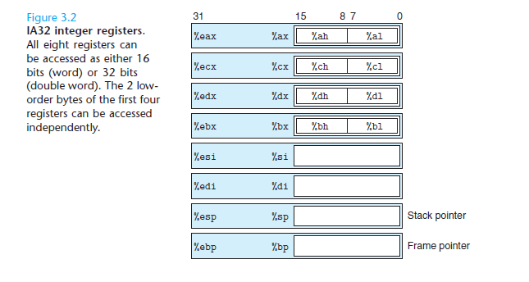
x86_64
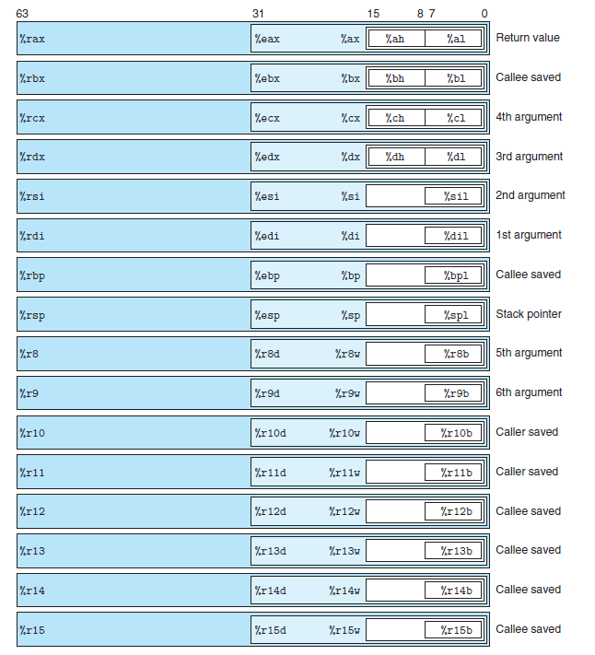

Argument Passing (x86-64)
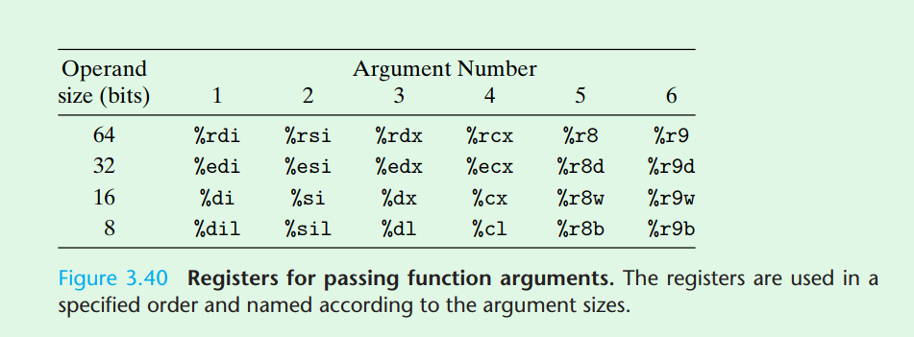
Arguments are passed in specific orders as above.

Data Movement Instructions. Page 205
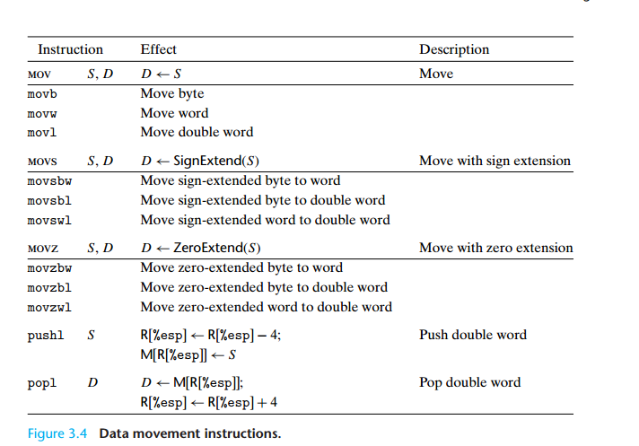

x86-64 Data Movement
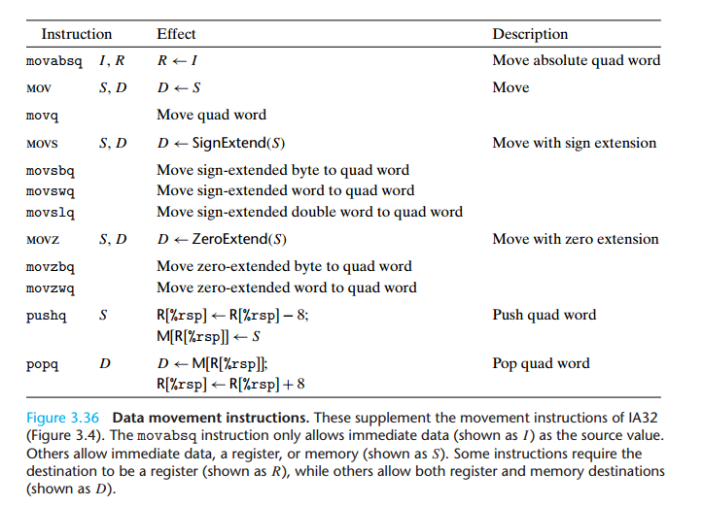
movabs $0x400921fb4d12d84a, $eax
movabs: move a full 64-bit value or a 64-bit absolute memory address.

Integer Arithmetic Operation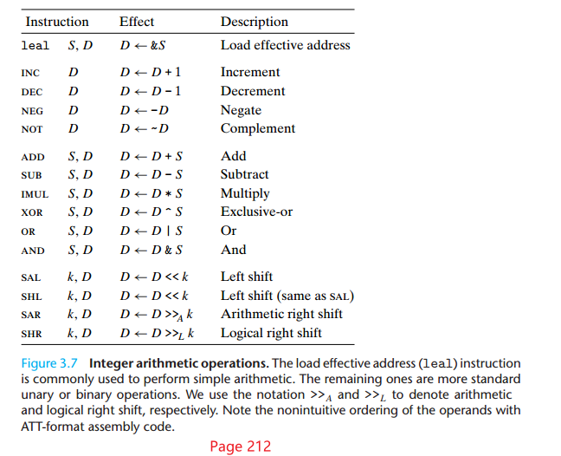

Special Arithmetic Operations
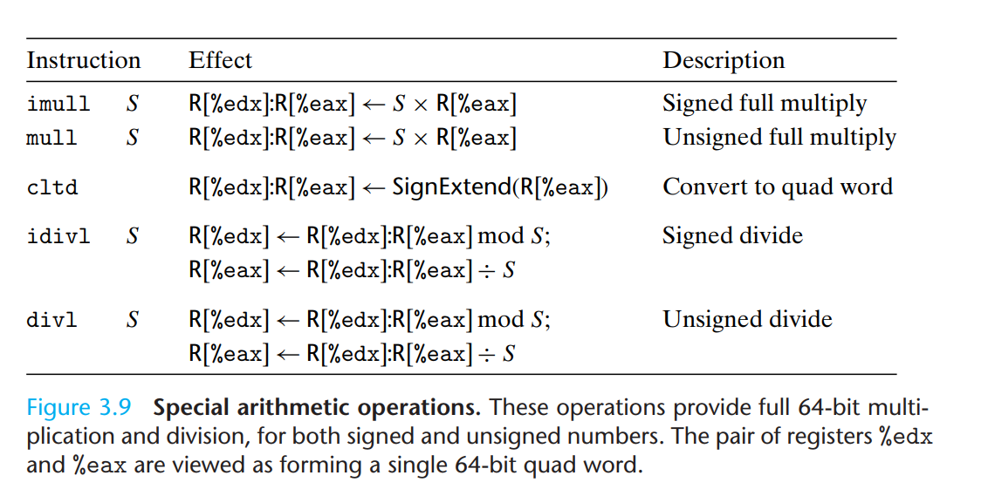

Conditional Codes (Page 219)
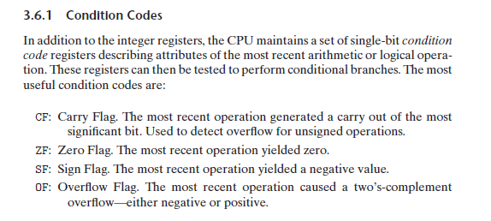

The SET instructions
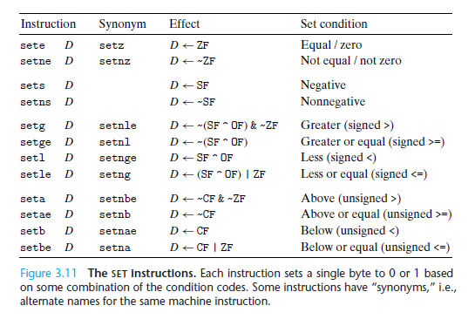

Comparison and test instructions. Page 220
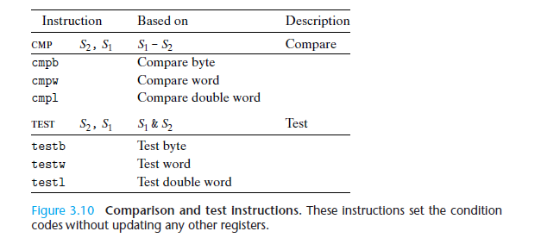

The jump instructions. Page 224
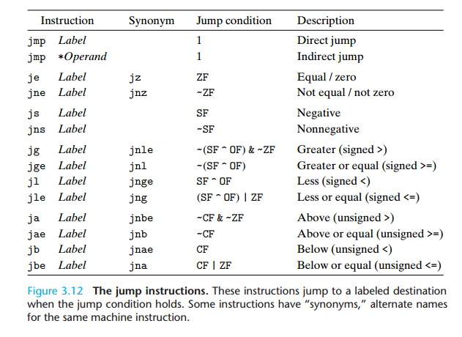

Conditional Move Instructions
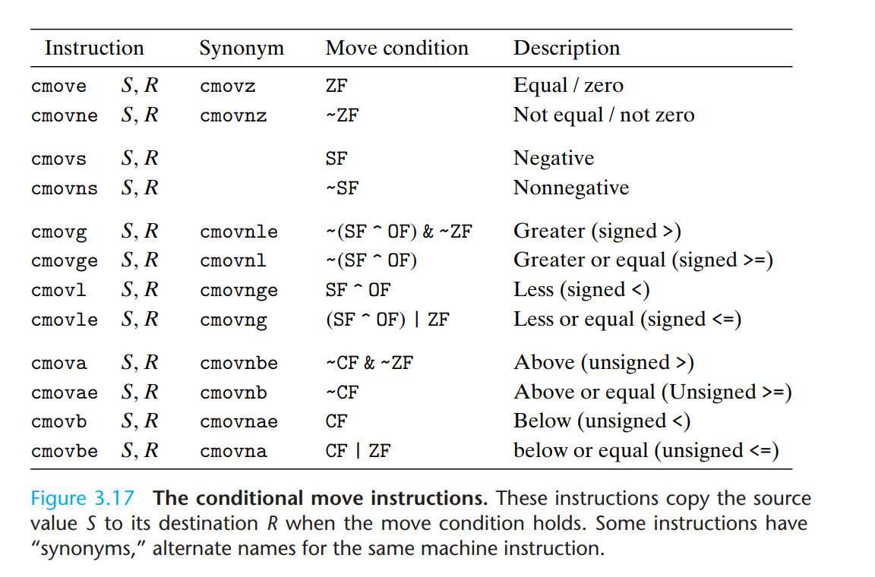

Y86 Instruction Set Page 372
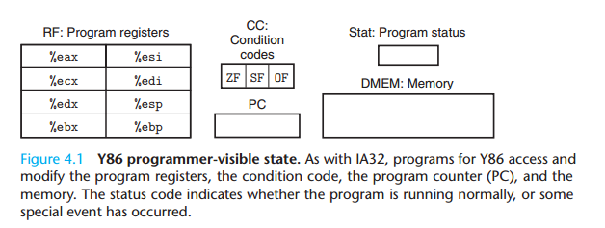
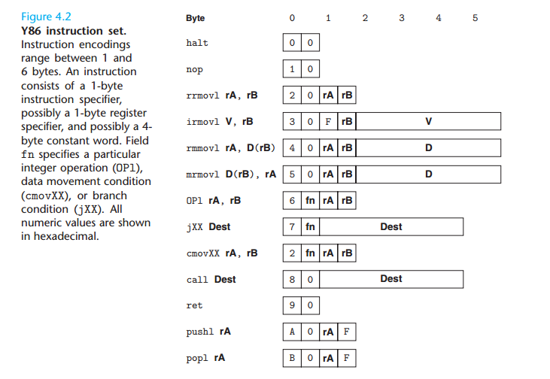
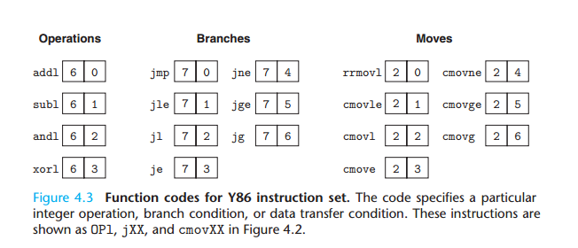
Note that in the above conditional moves “l” doesn’t represent “double words” as in “movl”, but represents “less”.

Y86 Register Identifiers

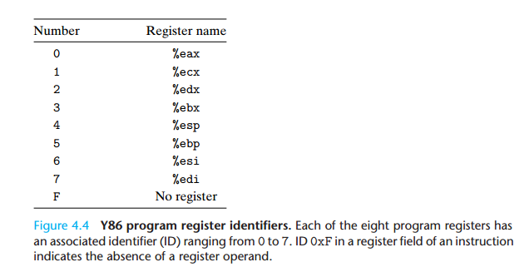

Figure 4.26 Constant Values Used in HCL Descriptions
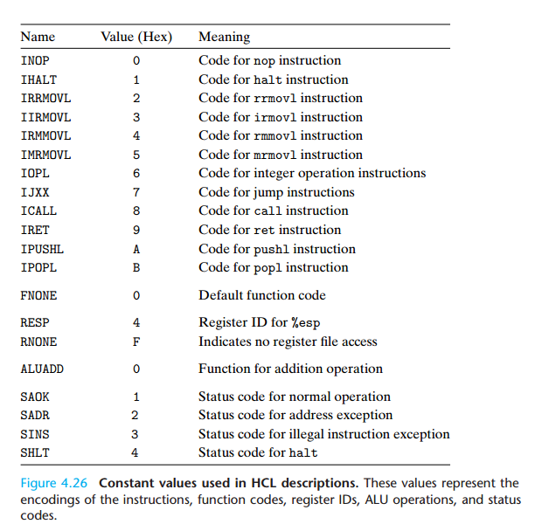

Computational in Sequential Implementation of Y86
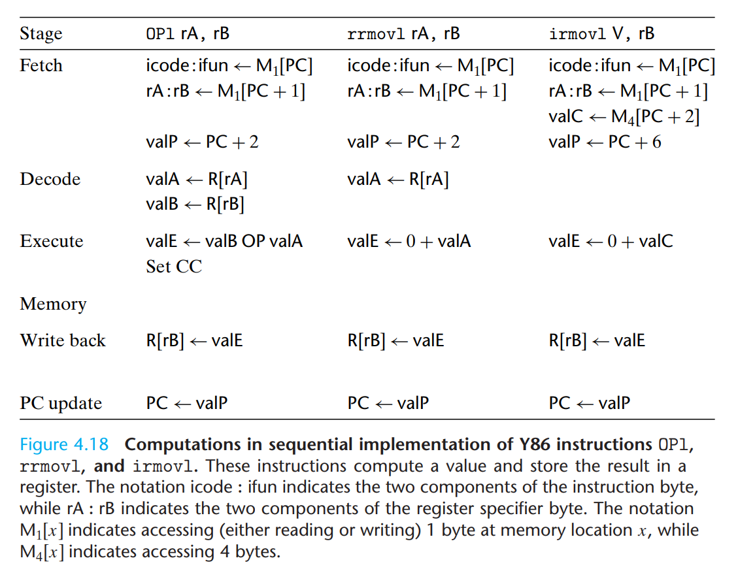
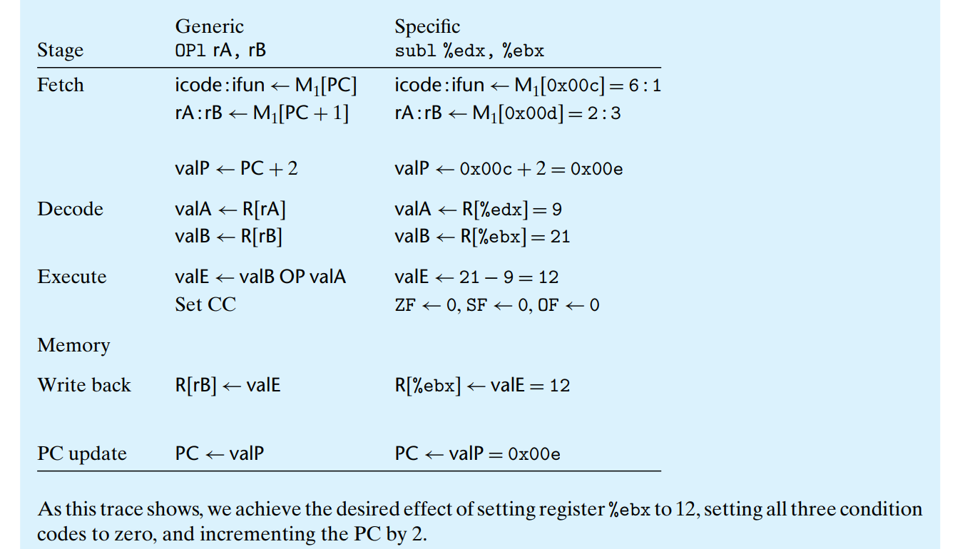
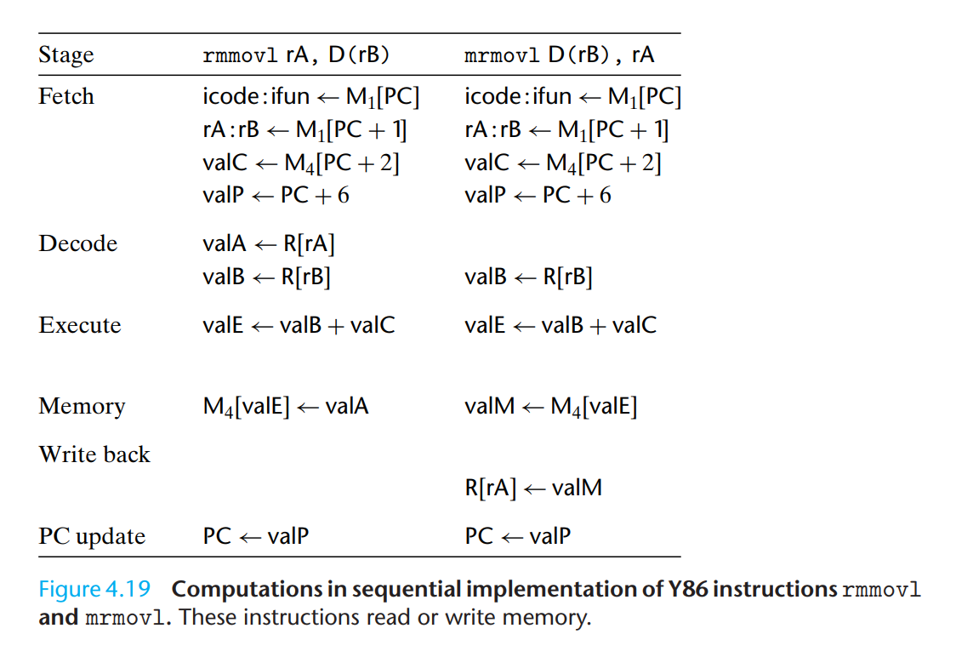
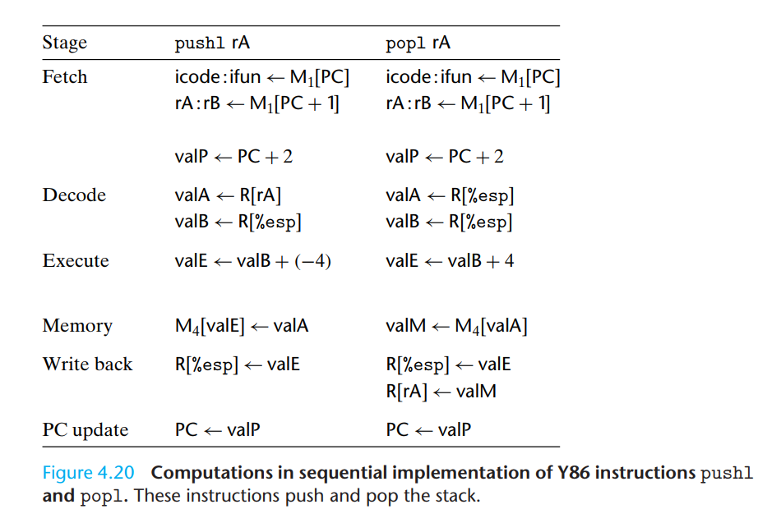
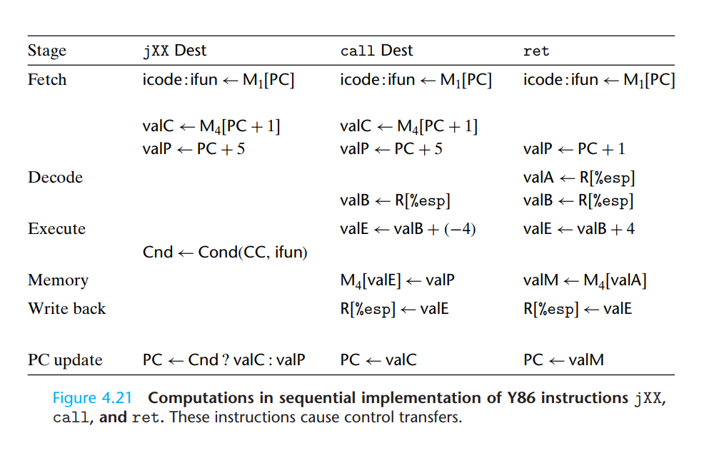
Conditional Moves (The is no figure for this instruction, it is a practice problem).
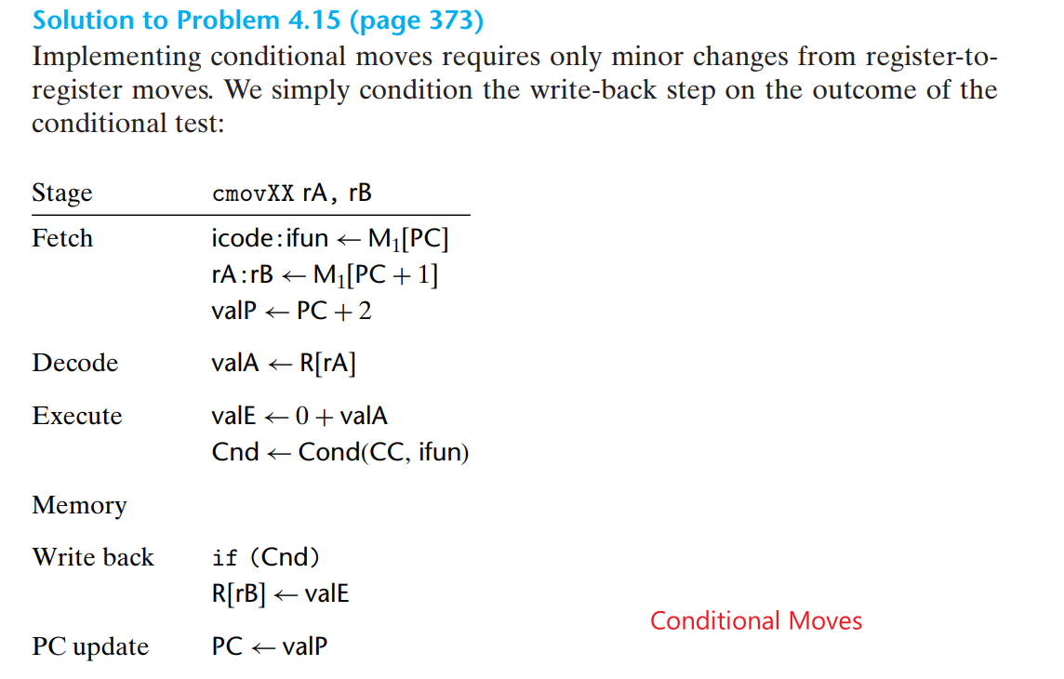

Hardware Structure of SEQ
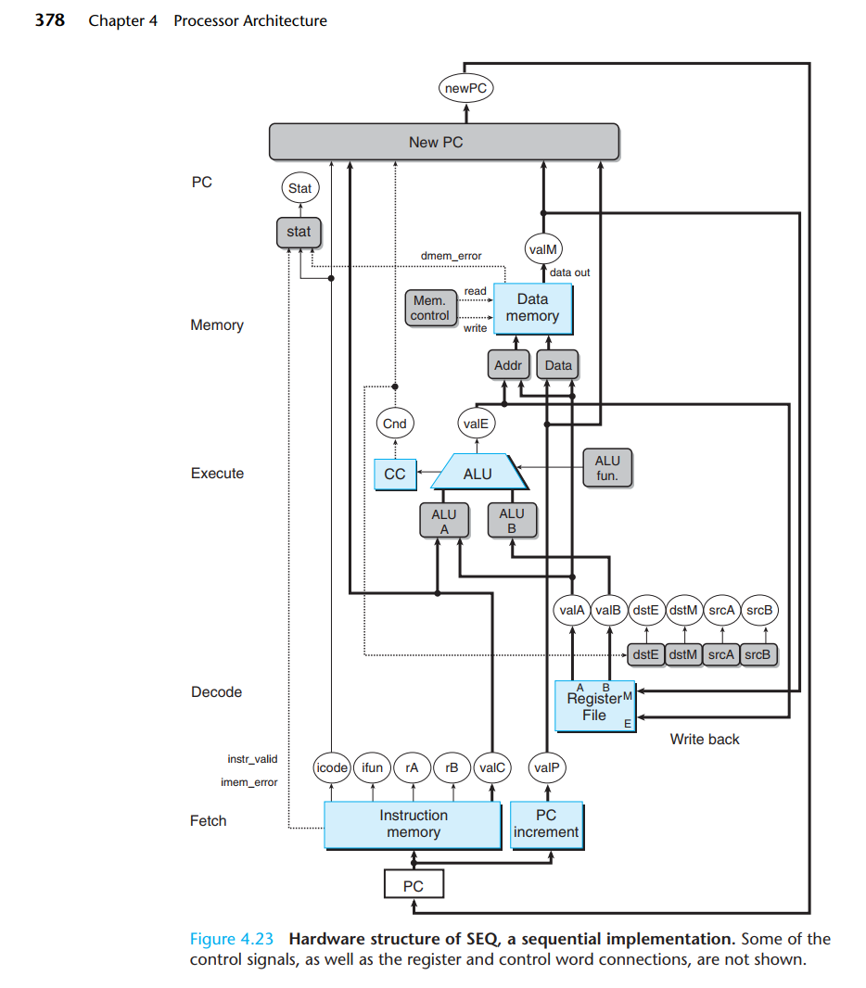

SEQ Memory Stage
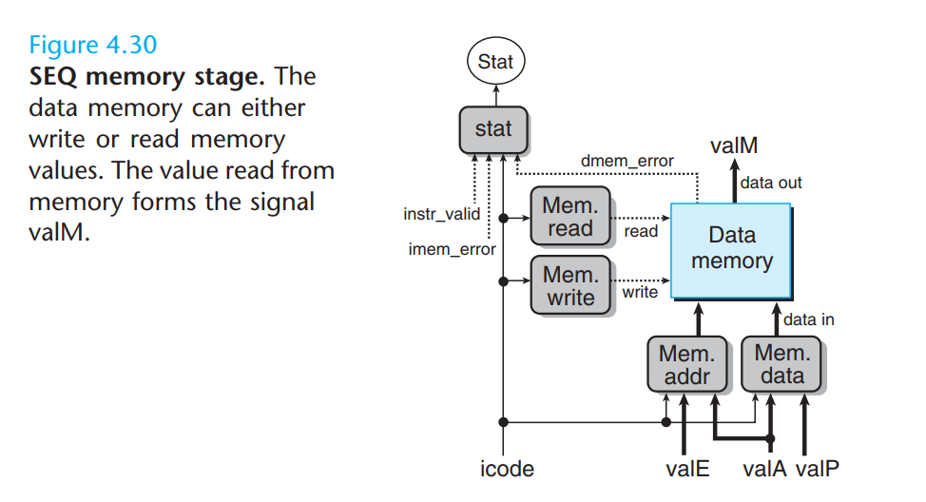

SEQ+
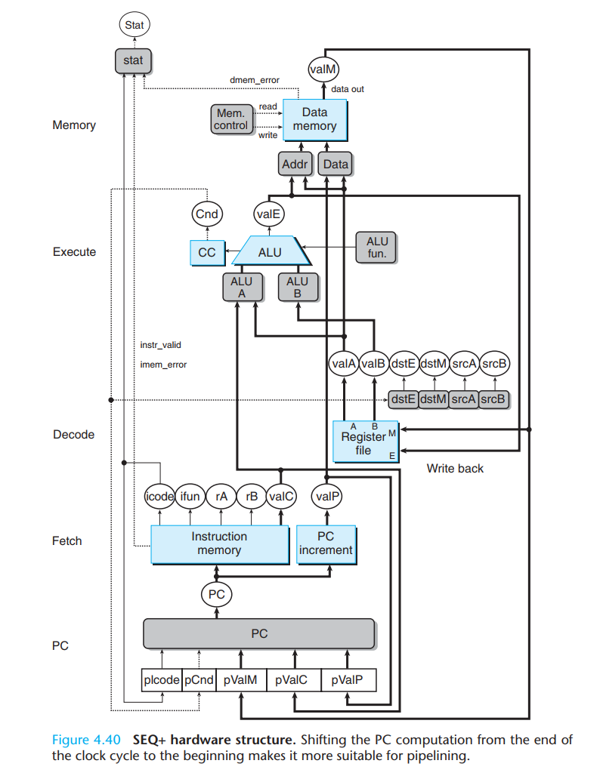

Pipe-
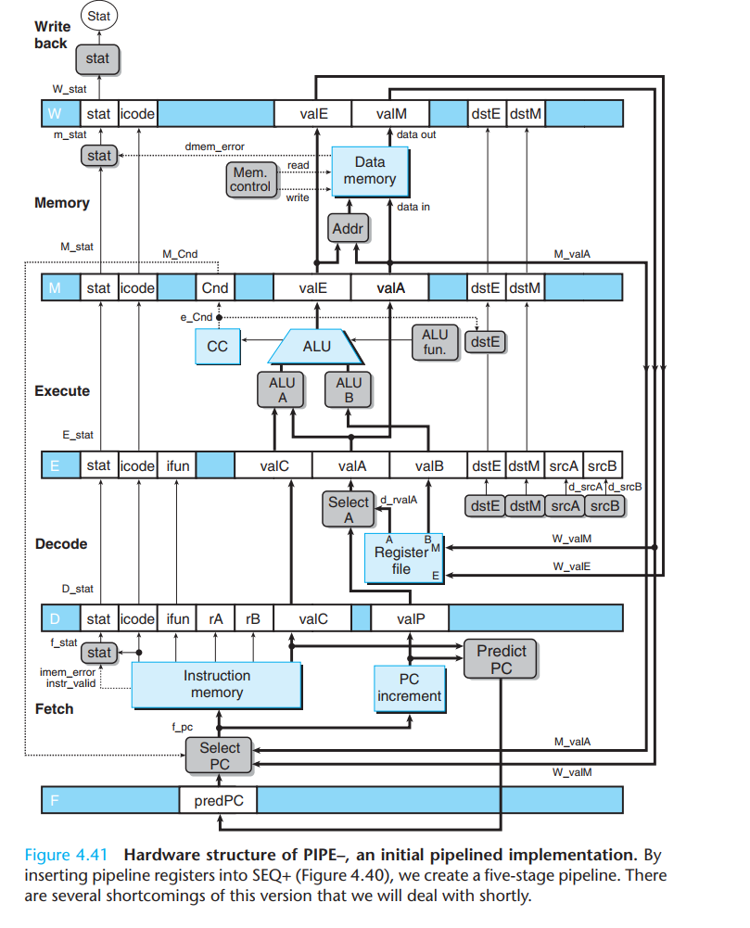

Pipe
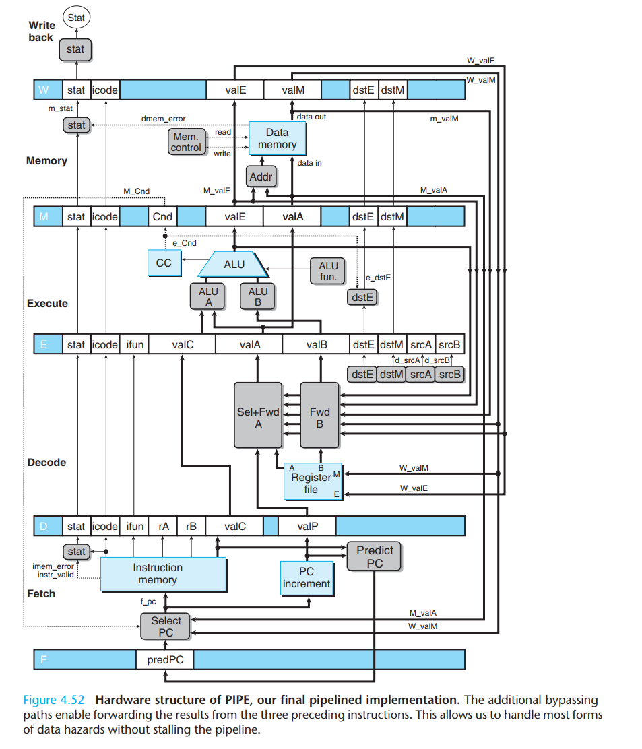
Why is there a “m_stat” with a lower case of “m”, but isn’t there a “w_stat” with “w” in the Write back stage?
The reason is that the Write Back stage doesn’t cause errors, the value of “W_stat” is passed from the Memory Stage. “m_stat” represents an error generated by the logic in the Memory Stage, while “M_stat” is the value in the pipeline register M.

Figure 4.55 PIPE PC selection and fetch logic
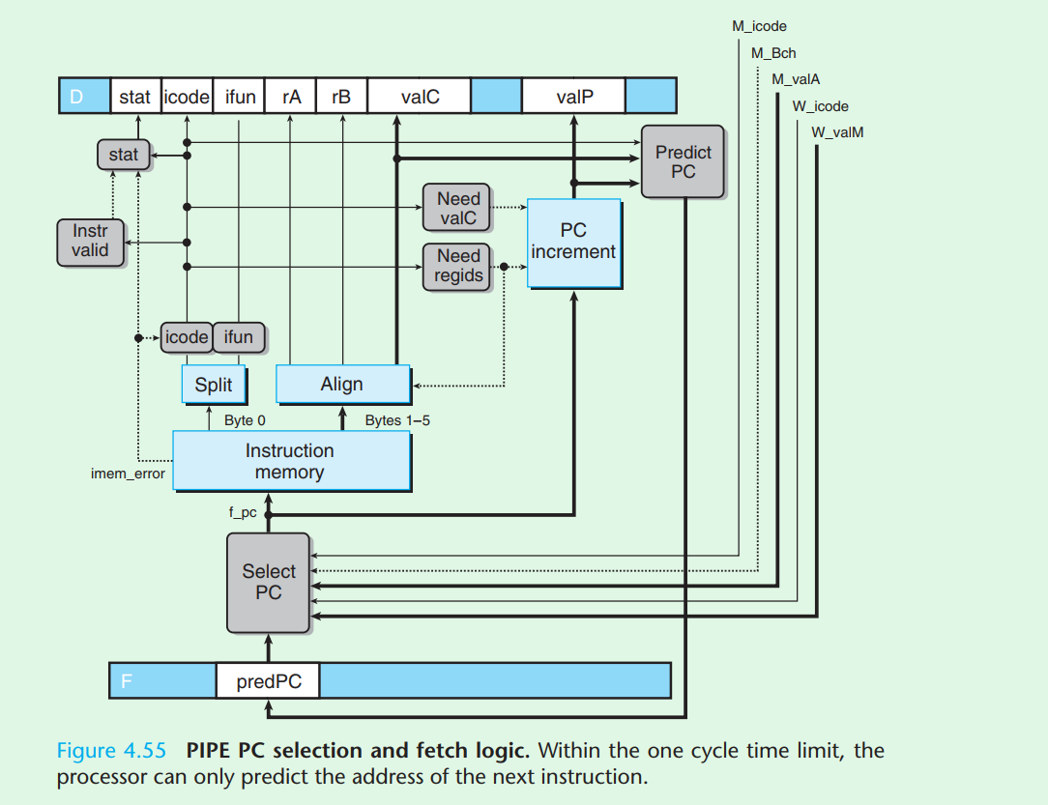

Figure 4.56 PIPE decode and write-back stage logic.
